Final Project – Screenshots

COMP609 – Application Development

Here are the screenshots taken of my program.

# GUI:

# Launch:

During launch, you will be asked to connect to a database. You’ll need to find a database to open, connect to that database then create the dictionary for it. (**Note:** “Connect”, “Disconnect” and “Create Dictionary” will be greyed out until there is a file path available. “Disconnect” and “Create Dictionary” will be greyed out if there’s no connection. “Connect” will be greyed out if there is an active connection.)

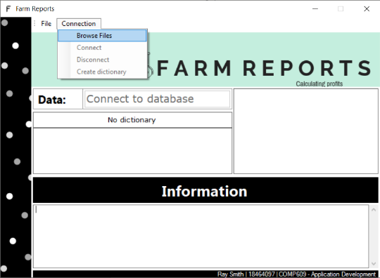 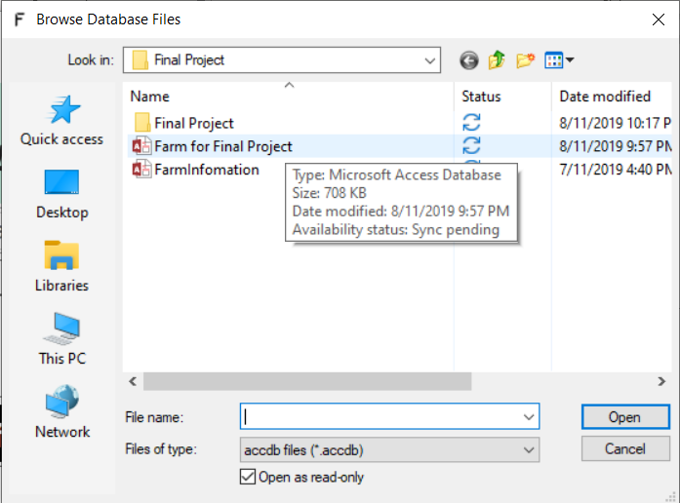 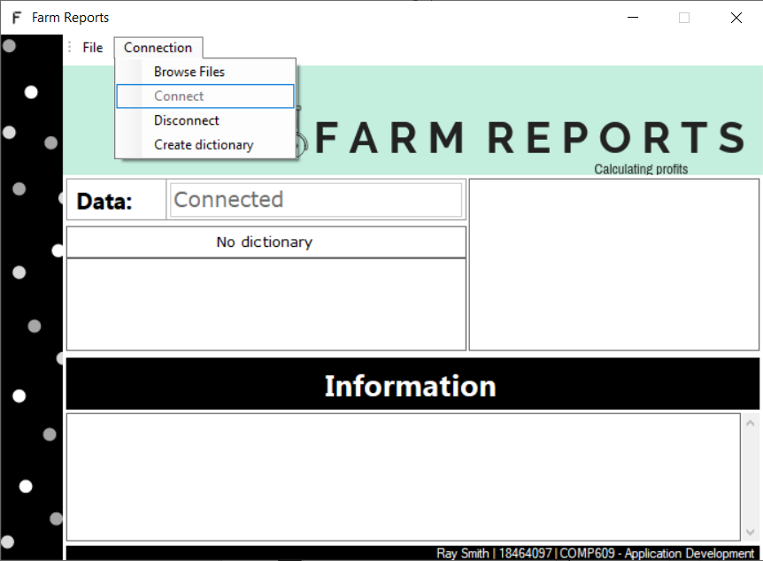

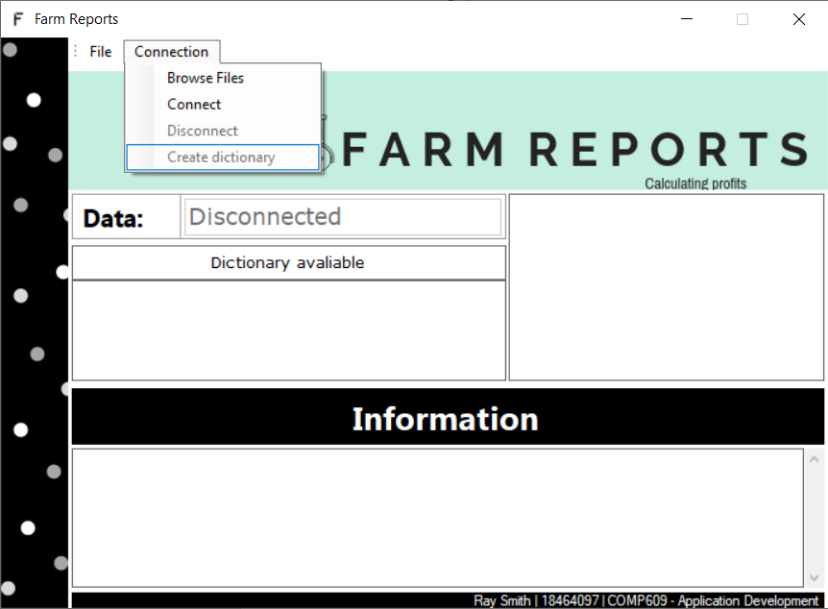

# Reports for Search:

# 

## Report 1:

This report opens a new WindowsForm and requests an ID number from the user.   
 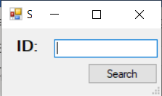

If the user requests a correct ID number, one of the following four screenshots should appear.

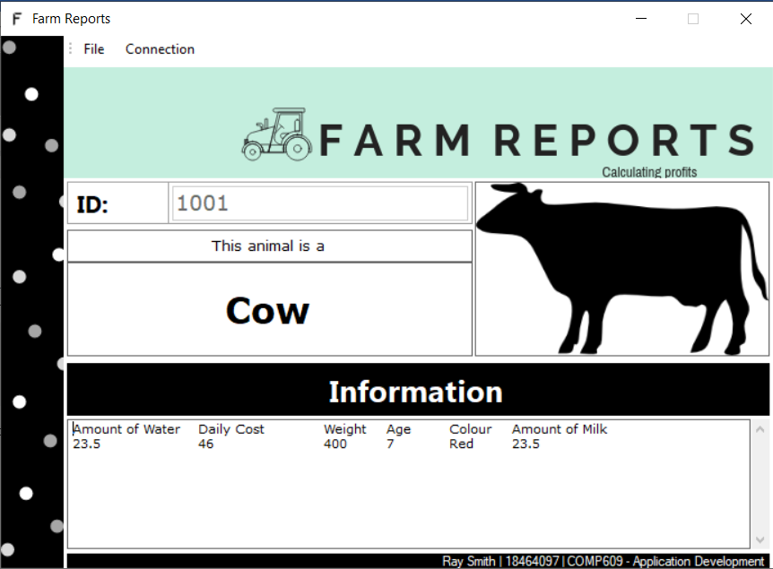 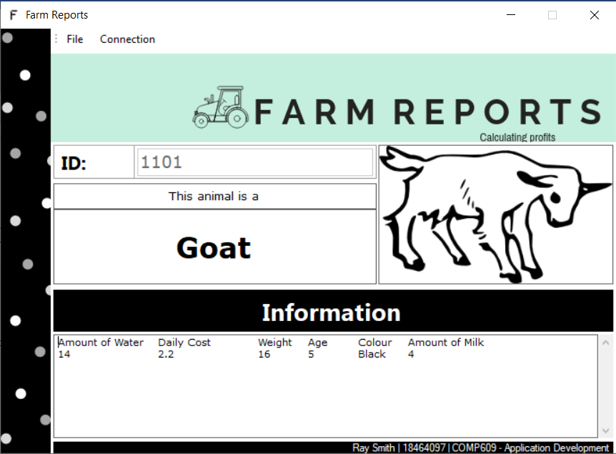 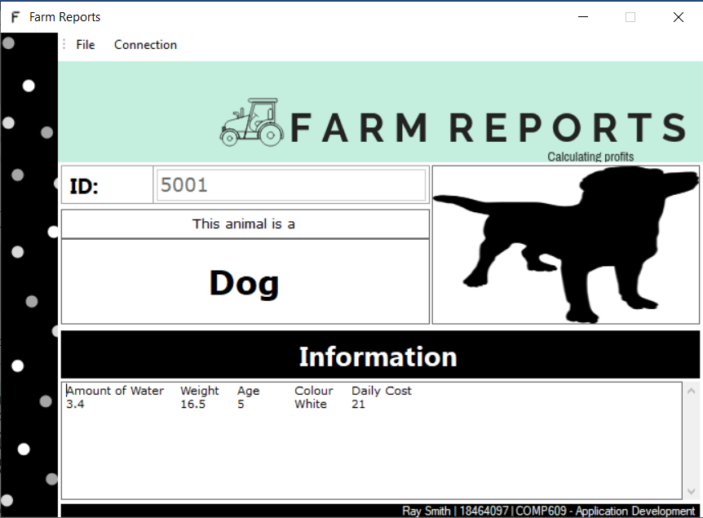 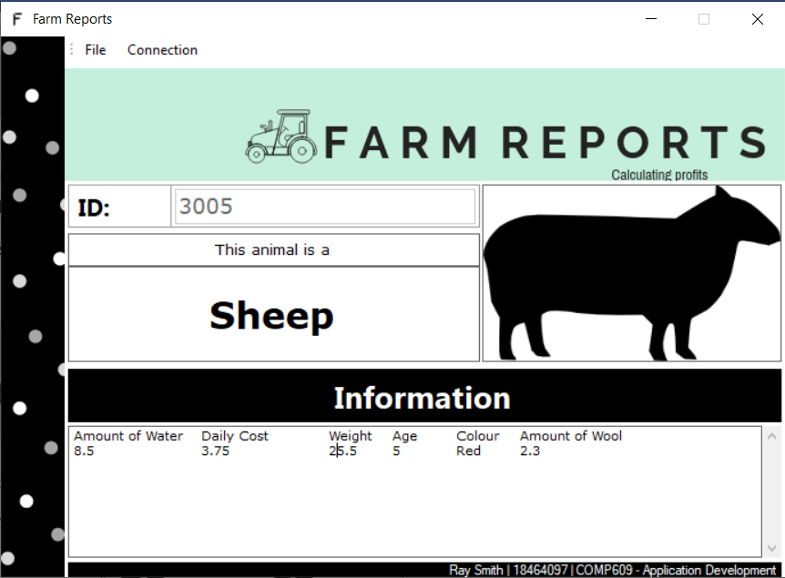

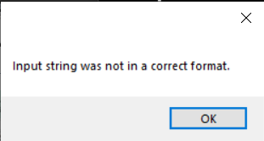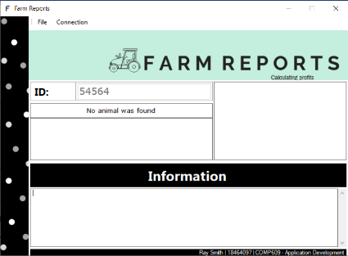

If the user requests a non-interger, this screenshot should appear.

If the user requests an incorrect   
ID number, this screenshot   
should appear.

## Report 11:

This report will open a new WindowsForm and requests a year (age).  
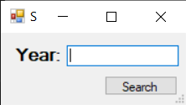

It will then display how many animals there are, how many animals that are older than the specified age, how many are younger, how many are the specified age and the ratio.  
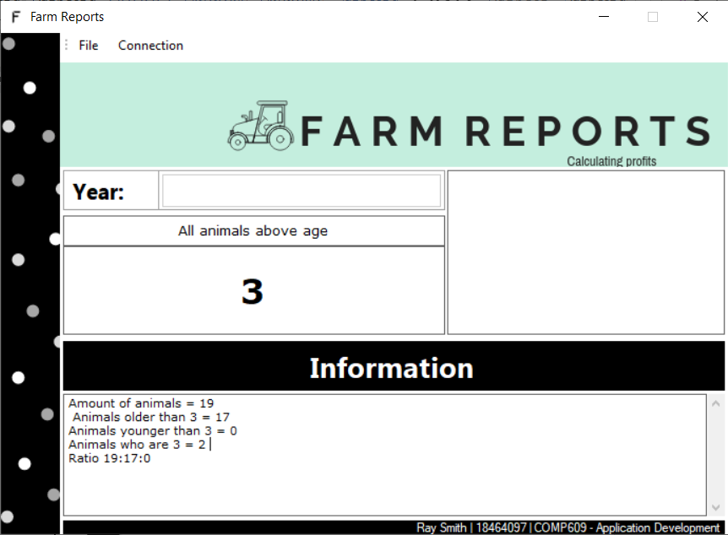  
However, if there are errors, the following screenshot will appear and “0” will be used as the value.  
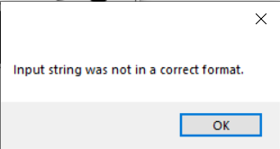n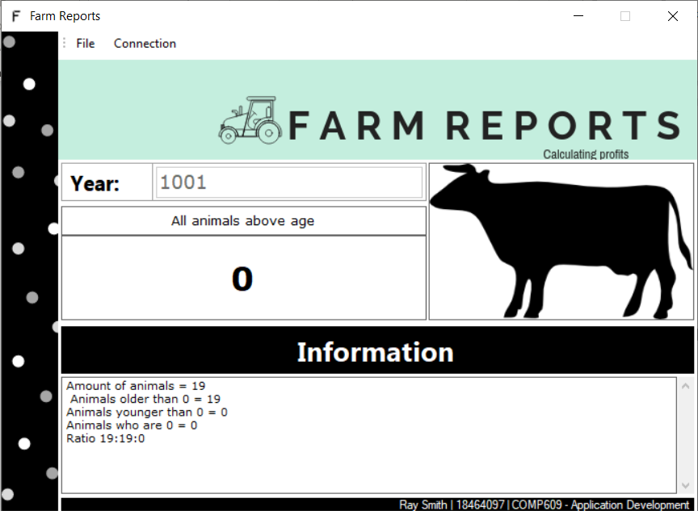

# Reports for Report:

# 

## Report 2:

This report displays the total profitability of the farm per day.  
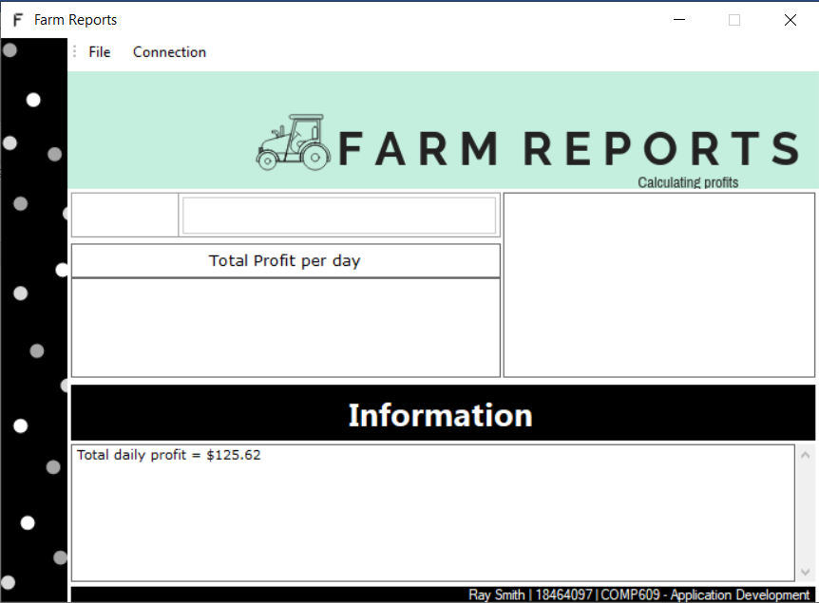

## Report 3:

This report displays the total tax paid to the government per month.

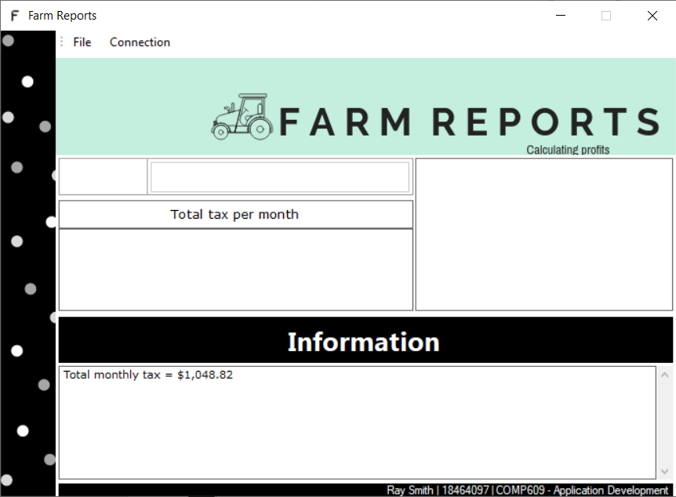

## Report 4:

This report displays the total amount of milk per day for goats and cows.  
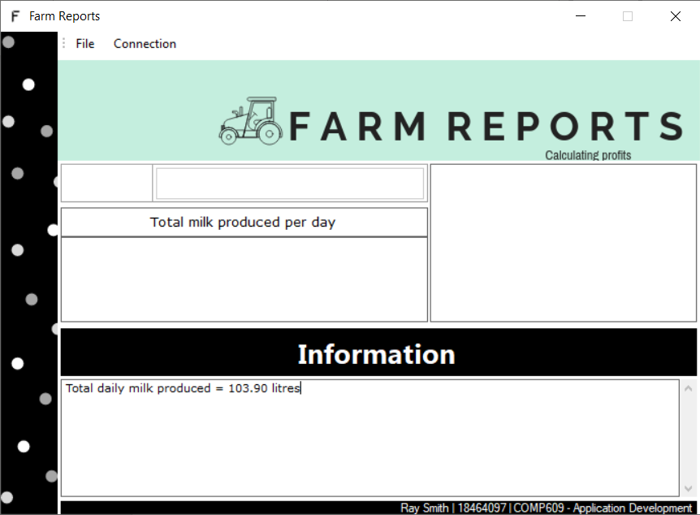

## Report 5:

This report displays the average age of all animal farms (excluding dogs).

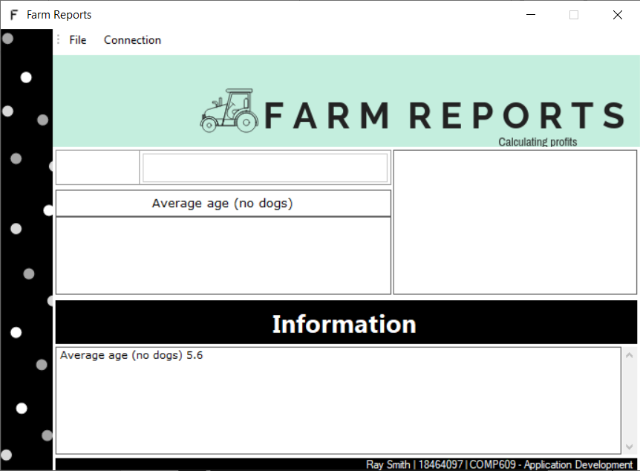

## Report 6:

This report displays the average profitability of Goats and Cows compared to sheep per day, per month and per year.

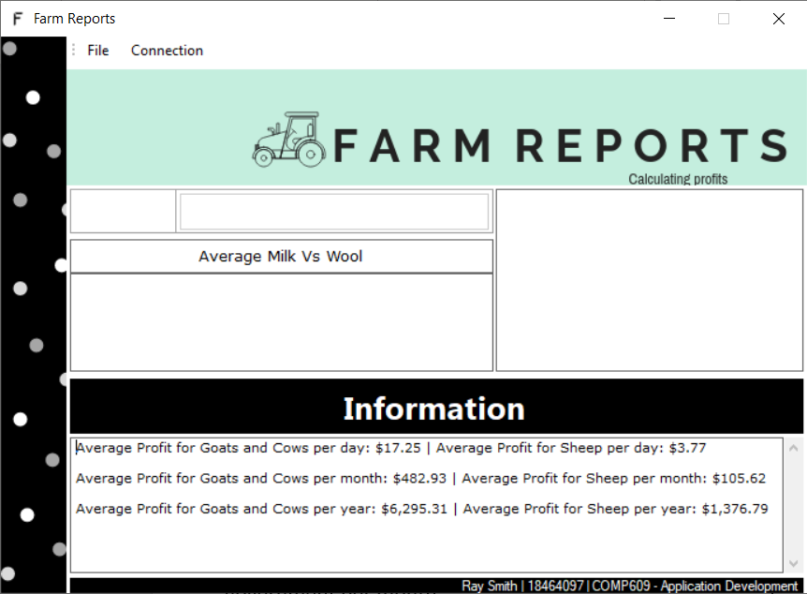

## Report 7:

This report displays the ratio of dogs’ cost compared to the total cost per day, per month and per year.  
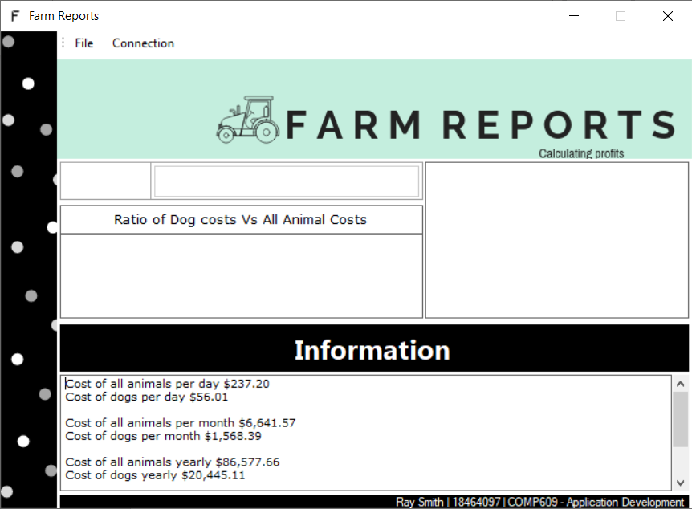

## Report 9:

This report displays the ratio of livestock with the color red.  
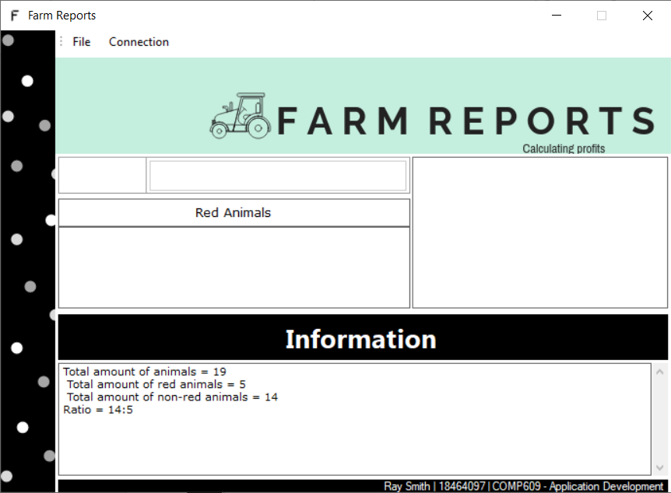

## Report 10:

This report displays the total tax paid for Jersey Cows per day, per month and per year.  
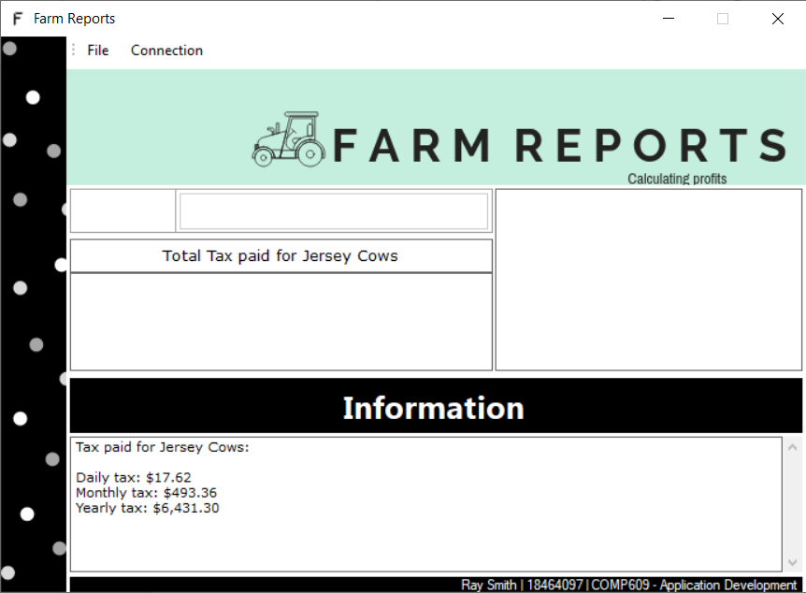

## Report 12:

This report displays the total profitability of all Jersey Cows.

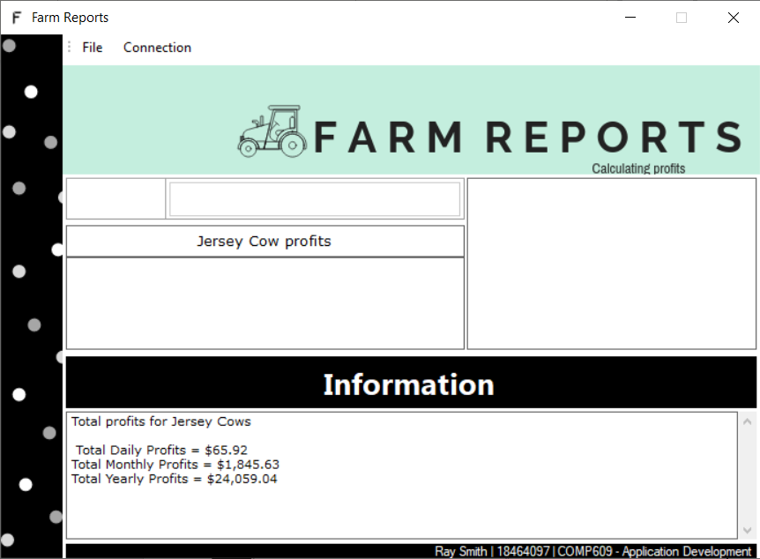

# Reports for Exporting:

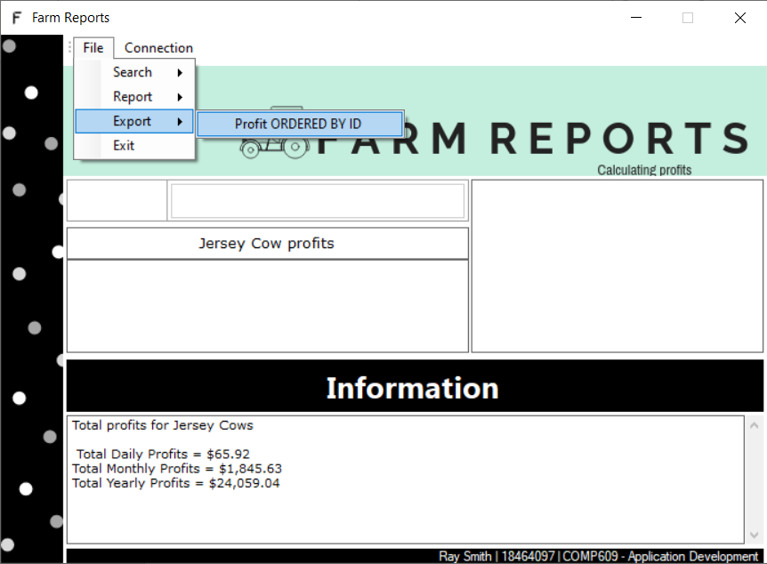

## Report 8

This report will sort all IDs in order of Profitability. It will list the animal, ID and profit. A .txt file is then generated after. 